Jenkins with nexus:

Step 1: We need to move below mentioned path.

>> cd /usr/local

>>sudo mkdir nexus 🡪 to create the directory

Step 1: Download the nexus package using below command.

>> wget https://sonatype-download.global.ssl.fastly.net/nexus/oss/nexus-2.11.3-01-bundle.tar.gz

Step 2: Now, we need to un tar the file

>> tar -xvf nexus-latest-bundle.tar.gz

After the untar we will get the below directory.

>> nexus-2.11.3-01

Step 3: Now, we need to create the new directory and copy files fromnexus-2.14.11-01 to nexus directory

>> mkdir nexus

Step 4: Now, we need to create the soft link

>> ln -s nexus-2.11.3-01/ nexus

Step 5: Now we set the environmental or nexus_home

>> vi /etc/profile

export NEXUS_PLATFORM=linux-x86-64

export NEXUS_HOME=/usr/local/nexus-2.11.3-01

export NEXUS_EXEC=$NEXUS_HOME/usr/local/nexus-2.11.3-01/bin/$NEXUS_PLATFORM

export PATH=$NEXUS_EXEC:$PATH

step 5: we need to edit nexus file

vi <nexus-how>/bin/nexus

#RUN_AS_USER= 🡪 by default like we need to un-comment enter the user name inside double code “ ”

RUN_AS_USER="root"

Step 6: export the user name

>> export RUN_AS_USER="root"

Step 7: Now, we need to start the nexus using below commad

>> nexus start

Step 8: next we need to go our favorite brow then

>> <http://3.83.175.228:8081/nexus/>

Nexus integrate with Jenkins:

Step 1: we need to install the nexus plugin from Jenkins dashboard

>>click on manage Jenkins

>> next click on manage plugins

>> Here we need to click on available then search plugin using search plugin(nexus)

>> Here we need to choose the nexus platform then click on install

Step 2: Now we need to configure the nexus details. We need to go manage_jenkins 🡪configure -🡪click sonar nexus fill the all the details click on apply and save

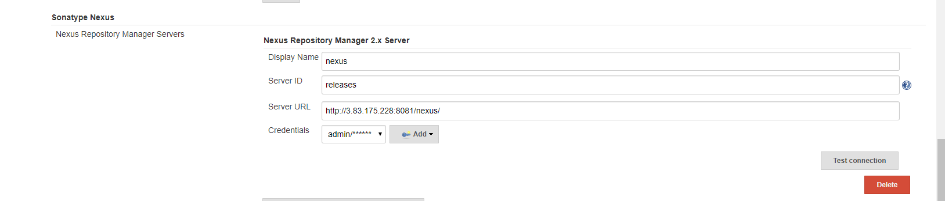

Step 3: We need to edit the pom.xml file

< distributionManagement>

<repository>

<id>releases</id>

<name>Releases</name>

<url>http://3.83.175.228:8081/nexus/content/repositories/ </url>

<snapshots><enabled>true</enabled></snapshots>

</repository>

</distributionManagement>

Step 4: we need to edit the setting.xml file then add the below code this file

<server>

<id> </id>

<username></username>

<password></password>

</server>

Step 5: Now we need to create the new job then configure nexus as shown as below screen shot.

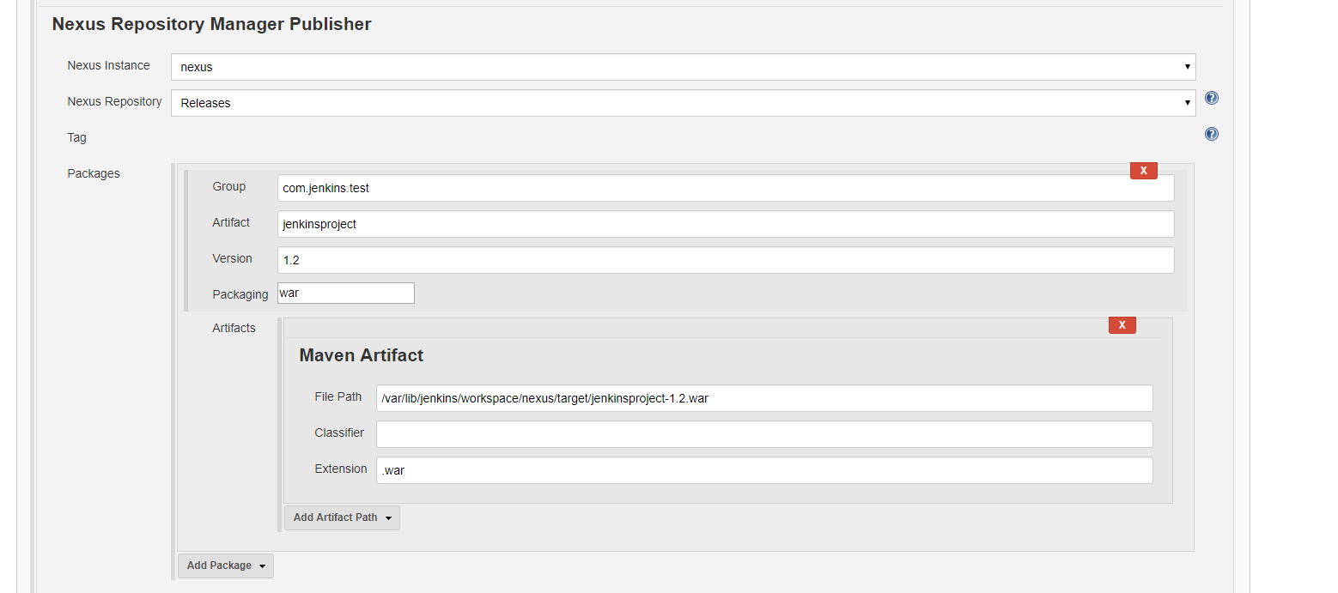

Step 6: click on the build now. If build is complete successfully, war file deploys to the nexus.

